CP01_BASK_DomainModel

Brainstorming Results of Project Scenario

|  |  |  |
| --- | --- | --- |
| Brainstorming List | Classification Result | Rule |
| cougar health (1) | (A) Cougar Health | 1(e) |
| is a (9) | (I) Is a | 9 |
| health insurance company (1) | (C) Health Insurance Company (HIC) | 1(a) |
| to facilitate (3) | (AS) To facilitate (Cougar Health, others) | 3 |
| sharing of information (3) | (AS) Sharing of info (Cougar Health, healthcare service providers, patient enrollees) | 3 |
| healthcare service providers (1) | (C) Healthcare Service Providers (HSP) | 1(a) |
| name (1) | (A) Name | 1(e) |
| benefits (1) | (C) Benefits they Provide | 1() |
| contact info (1) | (A) Contact Information | 1(e) |
| address (1) | (A) Remittance Address | 1(e) |
| (Optional) |  |  |
| bank name (1) | (A) Bank Name | 1(e) |
| acc. number (1) | (A) Account Number | 1(e) |
| rout. Number (1) | (A) Routing Number | 1(e) |
| patient enrollee (1) | (C) Patient Enrollee | 1(a) |
| name (1) | (A) Name | 1(e) |
| SSN (1) | (A) Social Security Number | 1(e) |
| plan id (1) | (A) Plan identification Number | 1(e) |
| individual id (1) | (A) Unique Enrollee id | 1(e) |
| contact info (1) | (A) Contact Info (Phone/Email) | 1(e) |
| primary enrollee (1) | (I) Primary Enrollee (Patient Enrollee) | 1(a) |
| address (1) | (A) Primary Address | 1(e) |
| depend enrollee (1) | (I) Dependent Enrollee | 1(a) |
| relationship (1) | (A) Relationship to Primary | 1(e) |
| software (1) | (A) Software | 1(a) |
| automate (3) | (AS) Automates | 3 |
| tasks (3) | (AS) Task | 3 |
| automate billing (3) | (AS) Automates billing for HSPs (Cougar Health, HSP) | 3 |
| view information about (3) | (AS) View information of Patient Enrollees (Cougar Health, Enrollees) | 3 |
| benefits (1) | (A) benefits | 1(e) |
| provided by (3) | (AS) Provided by (benefits, HIC/HSP) | 3 |
| insurer (1) | (A) Insurer | 1(e) |
| healthcare services (1) | (A) Healthcare Services | 1(e) |
|  |  |  |
| offers (3) | (AS) Offers two plans (Basic/Extended) | 3 |
| two (5) | (V) 2 | 5 |
| insurance plans (1) | (C) Insurance# Plans | 1(a) |
| basic (1) | (V) “Basic” | 1(e) |
| extended (1) | (V) “Extended” | 1(e) |
| similar benefits (4) | (V) Similar Benefits | 4 |
| different coverage (4) | (V) Different Coverage | 4 |
| different cost (4) | (V) Different Cost | 4 |
| plan year maximum benefit (1) | (V) Plan Year Max Benefit | 1(e) |
| out of pocket max (1) | (V) Out of Pocket Maximum | 1(e) |
| annual deductible | (V) Annual Plan Educatable | 1(e) |
|  |  |  |

UML Class Diagram

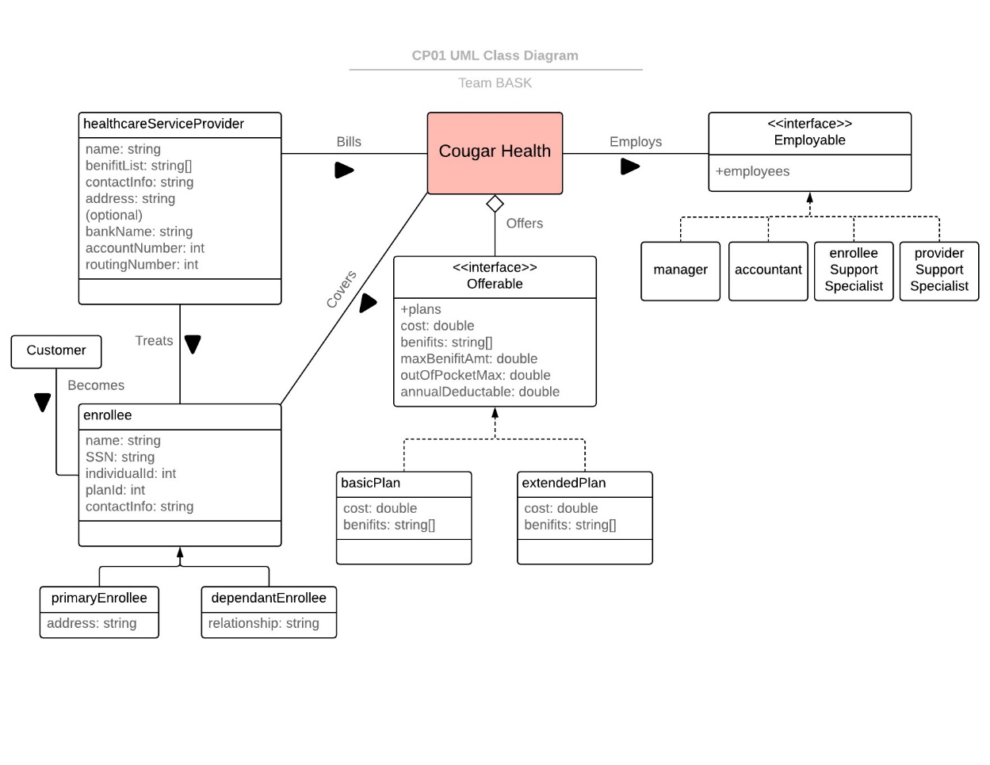

Abbreviation Table

|  |  |  |
| --- | --- | --- |
| **Identifier** | **Component** | **Description** |
| CH | Cougar Health | Start-up health care insurance company. Client for the software created. |
| CVR | Covers | CH covers an Enrollee. |
| OFF | Offerable | Interface for the plan classes. ‘basicPlan’ and ‘extendedPlan’ implement Offerable. |
| BP | Basic Plan | One of the two insurance plans offered by CH. Class implements offerable. |
| EP | Extended Plan | One of the two insurance plans offered by CH. Class implements offerable. |
| HSP | Healthcare Service Provider | Class for Service Provider information. HSP treats an enrollee, and bills CH. |
| BIL | Bills | An HSP bills CH. |
| TRT | Treats | An HSP treats an Enrollee. |
| CSM | Customer | A Customer is a potential Enrollee |
| BCM | Becomes | A CSM becomes an Enrollee. |
| ENR | Enrollee | Class for enrollee information. ENR is treated by an HSP, CH covers costs for an ENR. |
| PE | Primary Enrollee | Beneficiary of a health care plan. A PE can add dependents to their plan, modify their plan, view charges, etc. |
| DE | Dependent Enrollee | Dependent to the PE. May only see charges associated with that specific DE. |
| EPL | Employs | CH employs Employees. |
| EPB | Employable | Interface for employees such as the manager, accountant, enrolleeSupportSpecialist, and providerSupportSpecialist. |
| MNG | Manager | Class for a manager type of employee. |
| ACC | Accountant | Class for an accountant type of employee. |
| ESS | Enrollee Support Specialist | Class for an enrolleeSupportSpecialist type of employee. |
| PSS | Provider Support Specialist | Class for an providerSupportSpecialist type of employee. |